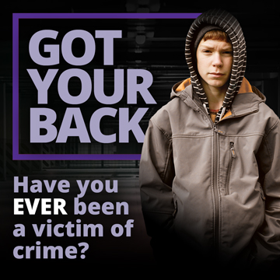

Halton Got Your Back Referral Form
Please email completed form to RJ.HUB@REMEDIUK.CJSM.NET
Or contact us on 0800 640 6466

Agency Referring:
Contact Name. Email & Tel Number of referrer:
Date of referral:

Victim Personal Details

Name:
Address:
Date of Birth: |  | Age:
Tel No: |  | Mobile No:
Best time to contact:
Parent/Carer details & telephone number if relevant:

Crime Details

Niche Number:
(if applicable)
Offence:
Date of Offence:
Any other details relating to the offence
Additional Information
i.e. learning /communication needs
Prevention Orders
Family relationships
Health or Wellbeing
Has consent been obtained from the Parent / Carer to provide contact details to Got Your Back Victim Support Service?

